CSC258 Lab5 Prelab

Prart 1 1. schematic

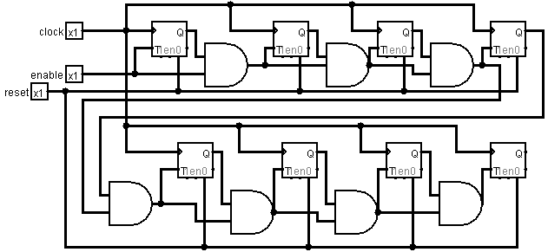

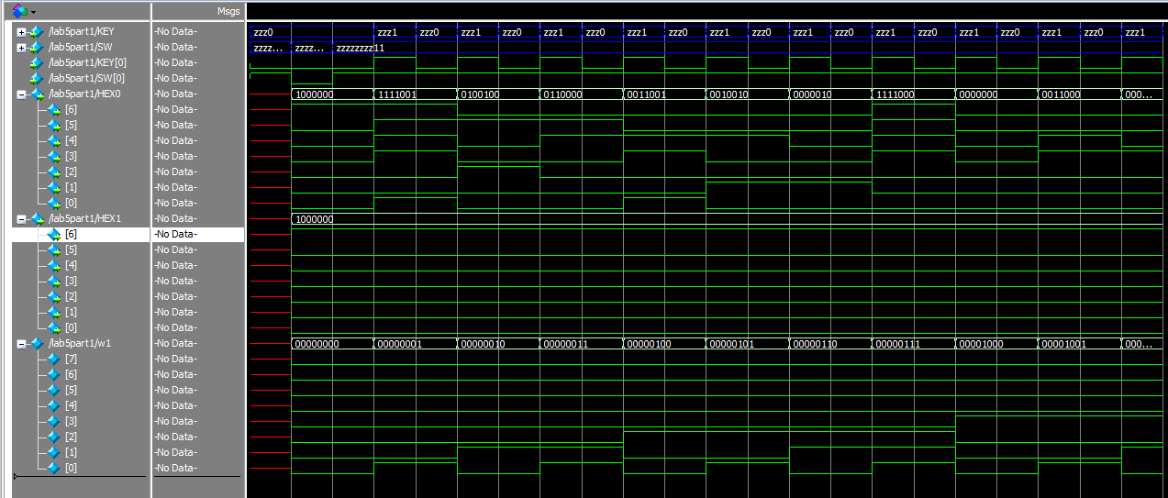4.

5. a) The Logic utilization (in ALMs) is 14/32,070 (<1%)

b) I cannot find the report. But I guess it is 50MHz.

7. The T flip flop are vertically placed.

Part 2:

1. A counter with Log 2 5000000 = 26 to count to 50 million.
2. 